Part 1: The Innovation Itself – How The ROI Brain™ Works

Overview:
- The ROI Brain represents a new generation of analytics. It is now possible to take into consideration every major factor influencing sales, and measure the effect of every message to every person. Companies such as Allstate, Amgen, Best Buy, Citibank, Chattem, DSW, FOX and more use Marketing Evolution’s ROI Brain™ to measure and optimize their marketing.
- Marketing Evolution’s ROI Brain™ capabilities demonstrate that the biggest change in the past twenty years is the one-two punch of Big Data and AI. The ROI Brain performs in-campaign optimization at the person level, across all marketing touchpoints and has documented over $20 Billion in incremental profits annually to the 50 enterprise brands that have adopted the ROI Brain™.
- Marketing Evolution is demystifying the terms Big Data and AI by giving business people a look under the hood to see the specific data and analytics at work. Marketing Evolution has brought transparency to the process of connecting data from every media exposure, online and offline, to data for sales, brand perception, social, digital, location and more. By connecting all this data at the person level, and providing visualization, marketers can see which exposures to advertisements contribute to a sale, and why algorithms are adjusting targeting, creative rotation and media mix.

How it Works:
In the ROI Brain™, there are over 700,000 data points, from over 300 sources attached to each person.

1st Party: CRM data, website visitation data, view engagement with previews
- E.g. HBO subscribers that watch boxing, targeted directly on TV and in Digital, Location of each theatre playing the movie Creed.
2nd Party: Media owner + Marketer database (combined)
- E.g. Sports illustrated subscribers (Time Inc.) combined with those that engaged with the trailers online (Warner). Or Comcast Subscribers that viewed trailers.
3rd Party: Digital Behavioral data, SmartPhone location data
- E.g. “MasterCard_Frequent_Transactor-Entertainment/Movies.” Or, Geofence of theatre locations, or Facebook likes of Michael B. Jordon, Rocky Movies, or Sylvester Stallone.
4th Party: Propensity models to see movie based on Geo-location data & gravity models.
- Marketing Evolution calculation of person-level propensity, based on factors such as neighborhood, Facebook interests, search behavior, weather patterns, commute pattern and distance to theatre, and (importantly) exposure to advertising.

An example of what the ROI Brain™ analyzes is shown in the map below. This example is from Warner Bros. The map shows theatre locations (blue dots), Facebook like data (Green & Red area), with real time weather, geo-fencing and out of home billboards (orange dots) is shown. The algorithm automatically analyzes all the data combinations to recommend media tactics to optimize sales.

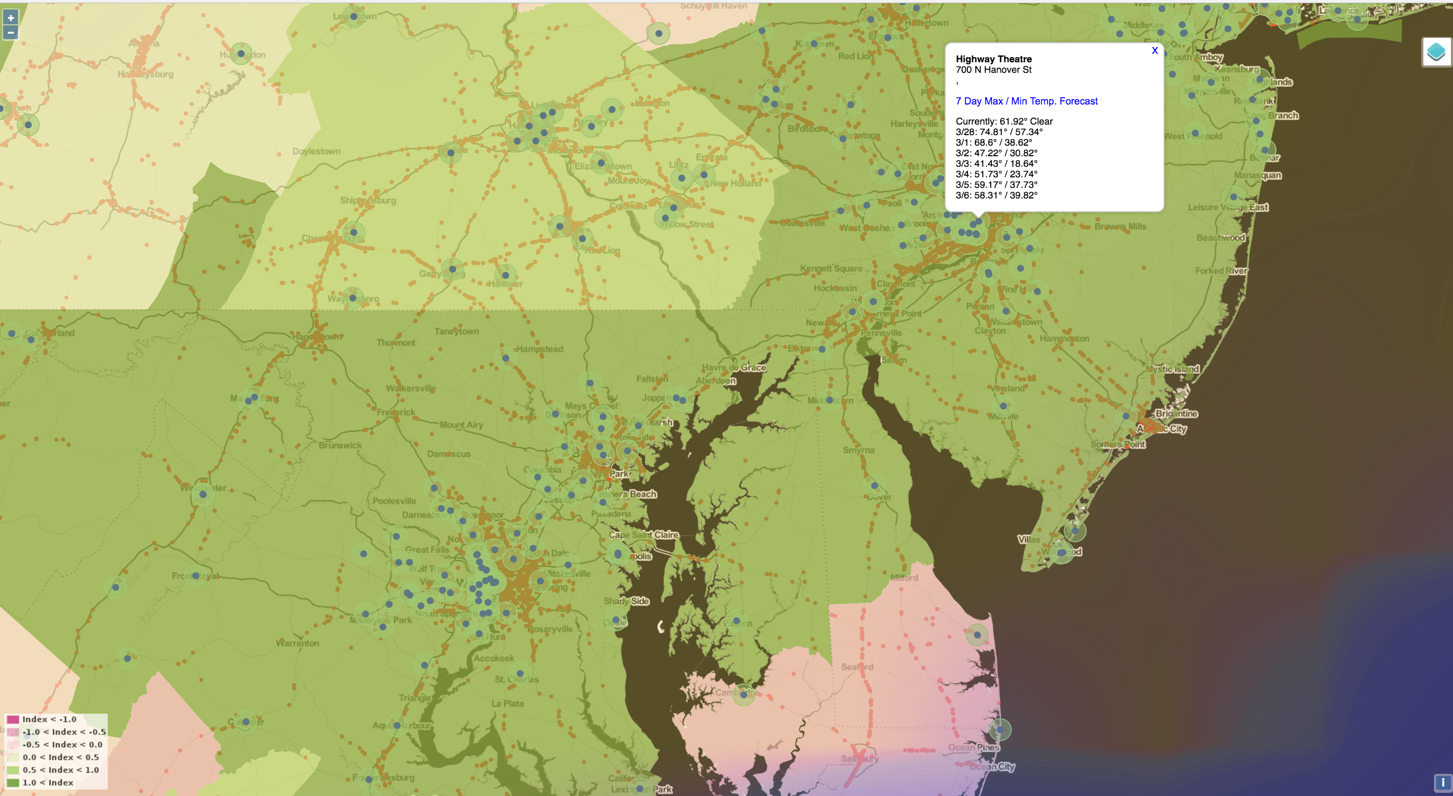

Below is a 30-minute video of the Warner Bros Case Study presented at the Salesforce/KRUX customer event: https://vimeo.com/177310630

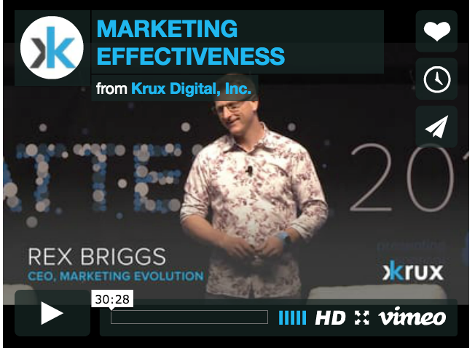

Additionally, CEB Marketing Leadership Council recently presented the use of the ROI Brain™ for Citibank. They named it “Best Practice.” https://ceb-event.adobeconnect.com/p58zrwwvfnt/

“Any sufficiently advanced technology is indistinguishable from magic” as Arthur C/ Clarke once observed. Marketers using our technology have commented that this is the first time they have ever seen all the pieces put together in one integrated platform. While we work hard to make it possible to see, touch and understand the ROI Brain’s analytics, it is remarkable to see all the data coming together, as seen in the chart below:

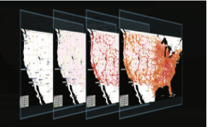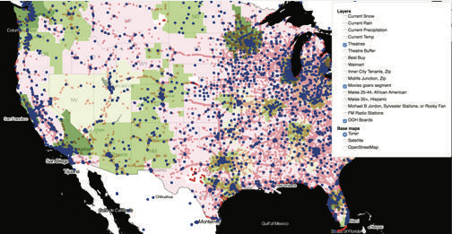

The central value proposition of the ROI Brain is optimizing advertising to increase sales and profit. Therefore, the ROI Brain starts off with the data you might expect, such as sales (at 4 o’clock in the chart) and advertising (at 8 o’clock). What makes the ROI Brain™ powerful is that it includes a vast amount of additional data, attached to individual people, organized in a Graph Schema.

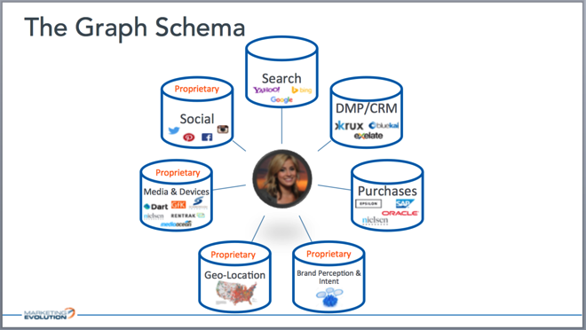
Figure 1: The Graph Schema, integrating all the data at a person-level.

There are five unique datasets integrated. First, at 11 o’clock on the chart, we link to person-level “DMP” and “CRM” data – this is where a business first party data such as customer purchase details is integrated to make marketing more personal. Second, working counter clockwise, we link search and person level social. Third, is the transformation of media spending into individual impression level exposure. Fourth, we link each person to their geo-location (where they live, work and shop). We calculate how far they live from the store or the point of distribution. We look at all the location specific factors, including local economy, weather, even individual out of home advertisements, geo-targeted messages. Fifth, we link brand perception and intent data.

All of this data is connected at a person level, and is connected directly to purchase data. This person-level linkage is what allows us to uniquely look at the combination of brand perceptions, attitudes and behaviors in the most accurate manner. This means we can prove the value of brand advertising to influence longer-term sales. It means we have the ability to calculate the leading indicators to see what intent signals are most predictive of future purchases.

We have over 700,000 data points attached to each person. This is truly big data. The ROI Brain™ has real-time integration of hundreds of data sources, including but not limited to: all digital log files, social media exposure, search activity, critics ratings, theatre locations, person-level tracking survey of consumer awareness, interest and intent, along with individual level exposure calculated for every person in the country for every form of advertising (TV, OOH, Mobile, Digital and Radio). (figure 2)

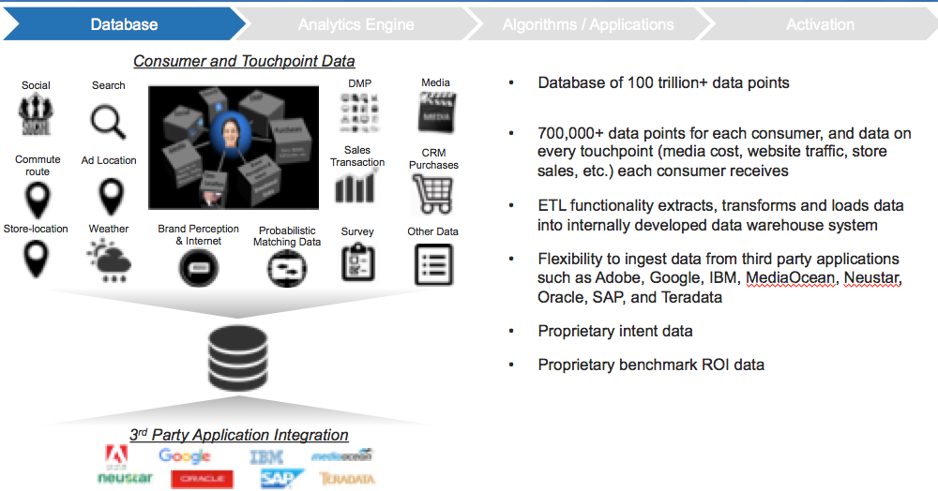
Figure 2: ROI Brain™ data processing, including theatre locations, frequent movie-goers, out of home ad locations, advertising exposure and more.

There are three things we do with all this data: First, we calculate purchase propensity for every person.

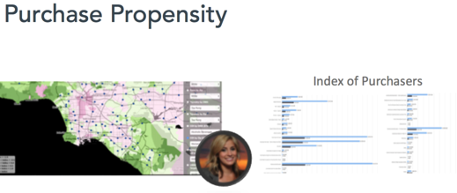
Figure 3: Person Level Purchase Propensity Calculation.

Meet Celeste (figure 3). She lives in Los Angeles. Shown on the map are dots for each store near her (or theatres in this case). We know the distance she has to travel to get to a store or theatre. Through automated analysis, we know how convenience, measured in travel time, effects sales conversion.

On the right side of the chart is her personal profile. The profile and her location allows the ROI Brain™ to calculate her probability of buying the product we are analyzing. Every person in the country is scored.

Second, we apply predictive analytics to purchase propensity. This includes factors the marketer controls, such as advertising. It includes factors the marketer doesn’t control, such as the economy, weather, competitive actions. While the marketer does not control the weather, or other factors, the marketer can be proactive in responding to these factors by adjusting the factors the marketer does control, such as pricing and advertising.

The third thing we do with the data is in-campaign advertising optimization. Some advertisements work better for certain people. The software detects which messages are influencing which people, and adjusts the creative rotation and media mix accordingly. The ROI Brain™ gets the right message to the right people.

Here is how it works in three steps:

Step 1: Calculate how many exposures the person has had to each media.
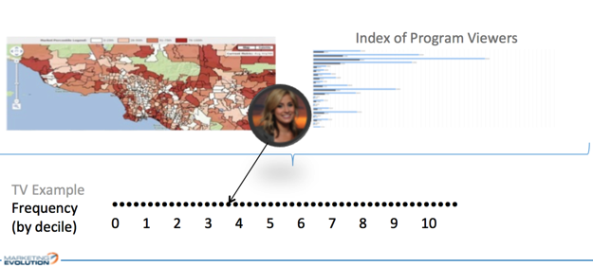
Figure 4: Conversion of TV Advertisement Insertion To Person Level Exposure

What you’re seeing in figure 4, comes directly from the media plan that tells us that this marketer was advertising a specific message, in a specific prime-time television network. We know the delivery of that prime-time television network TV in the Los Angeles area down to the household level. We know the composition of who is watching that TV program.

In Celeste’s case, her exposure level is between the 3rd and 4th deciles. What you’re seeing at the bottom of figure 4 are different dots. The dots are people. In this case, we’re only showing 50 people for simplicity, but in practice we analyze millions of people.

Step 2: Analyze the relationship between advertising and the key performance indicator, such as sales.

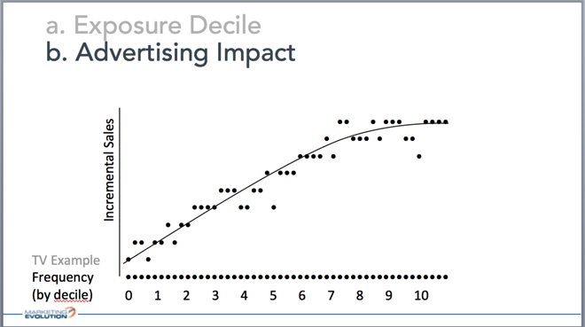
Figure 5: Person level Exposure Frequency to Impact Analysis

The dots are the same people, combined with Y-axis of sales. We can see that advertising exposure causes sales to go up (figure 5). With this advertising impact calculated, we can see that this ad worked. We can calculate the ROI.

Step 3: Marketing Evolution goes one step further beyond calculating financial return on investment from the advertising. This is where our ROI Brain™ becomes really powerful – this is where the AI looks for patterns to see whether or not the message works better with certain profiles of people (figure 6). Looking at the same people, we have color-coded different profiles. The left chart shows blue dots for males. They are more influenced by this particular message than females. To the right is a heat map, showing darker green for men. The lighter yellow for women means it’s still effective for women, but it’s just not as effective as it is for men.

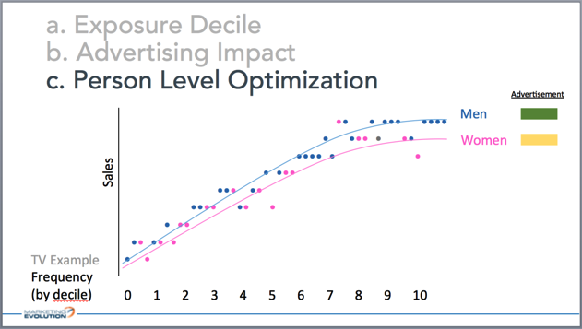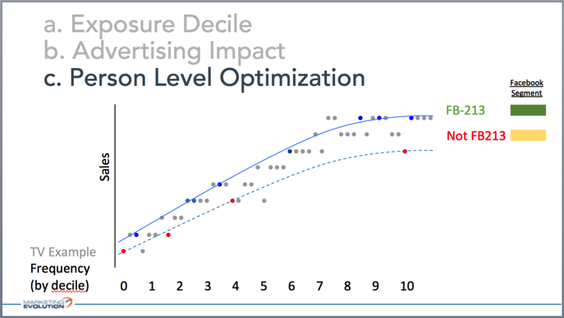
Figure 6a (left): Application of AI to find the differences in how people are influenced by the same message.
Figure 6b (right): TV advertisement analyzed by different Facebook Like Data

The software analyzes thousands of profiles looking for patterns. We analyze Facebook profile data (figure 6b) connected to TV exposure. We’re able to look at thousands of different profile variables including digital behavioral targeting, what’s going on with the weather patterns, local economy, you name it.

Figure 7 is what the marketer sees in the dashboard. At the top of the chart are all the ads ranked in relative overall effectiveness (each line is an advertisement). We can see ads like “Become,” “Life” and “Streets” are at the top of the stack. The software automatically adjusts the creative rotation based on this feedback loop. But that is just the start of the optimization. Below the overall impact by message is the heatmap showing the same ads, and the profiles of the people that are most influenced by each of these individual ads.

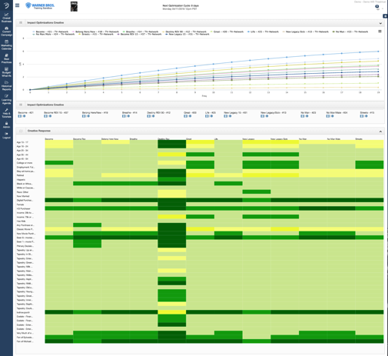
Figure 7: Advertisement analyzed live, ranked by impact, and heatmap of “right message to right person.”

Take a look at the ad that is on the bottom of the ranked line chart. That ad is called Destiny. If we look at the heat map below, we can see that it is the best performing advertisement for youth 13-24, Hispanic, African-American. It is the strongest in urban city zip code neighborhoods. So, for this specific segment, Destiny is actually the BEST advertisement. The ROI Brain™ takes every advertisement and figures out the population that is best served by the advertisement. It then determines if you should buy incremental media that hits the bulls-eye for this advertisement.
To bring this example to life, we captured a short video of the ROI Brain™ software:
https://www.dropbox.com/s/rjgdze8arsjq679/i-com%20ROI%20Brain%20software%20tour.mp4?dl=0
* This is not a professionally produced video, and should not be shared outside of judging.

The ROI Brain™ takes all the media placement options and all the creative messages options, and all the people, and optimizes line-by-line placement (figure 8).

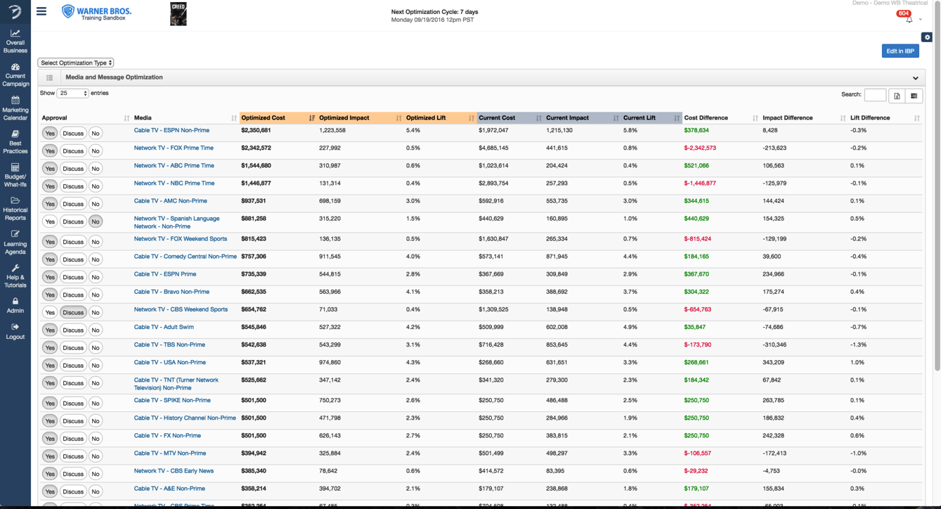

The optimization is more than matching the right message with the right people in the right media at the right price. The optimization algorithm factors in:
1. Impact
2. Cost
3. Reach & Frequency
4. Duplication & Synergy
5. Decay/Carryover Effects & Recency
6. Audience Selection
7. Message Response By Audience
8. Fully Addressable Media (delivered by DMP and other methods)
9. Constraints
10. External Factors/Competitive Factors
11. Human Over-ride

The software automatically simplifies the complex data integration and pattern recognition into easy to apply message and media mix optimization at the person level. A marketer can click on the recommendations to see why dollars are moving from one channel to another, or from one message mix to another, or from one person to another. This makes the results intuitive for marketers – directly linking the optimization to insights about how certain messages have a greater influence on certain profiles of people.

RESULTS:
Warner Bros increased ROI by 24 percent with the ROI Brain™. This increased ROI equates to an incremental $12 million in financial benefit per major movie release. Warner uses the software for all major releases, adding to over $100 million in incremental ROI and has experienced an ROI on Marketing Evolution’s data and analytic platform exceeding 3000 percent. According to a published statement from Laura Gross, VP Media and Measurement, “In contrast to mix modeling and attribution modeling, which we have tried, Marketing Evolution is far more actionable.”

Across the 50+ enterprise customers that have adopted the ROI Brain to date, the total incremental sales impact now exceeds $20 billion annually.

Today, the ROI Brain™ is primarily used by marketers spending at least $10 million a year on advertising. Marketing Evolution is democratizing the technology. Marketing Evolution is applying the technology to marketers concentrated in a single market. This works for big cities like New York, where Madison Square Garden Group is applying the ROI Brain™ to their iconic Christmas Spectacular show. It works in smaller cities too. In Reno Nevada, America’s biggest little city, YPO member David Farahi of Monarch Casino & Resort is deploying the ROI Brain™ for their Atlantis Casino and resort property. Today, with a newly release “big data for every business” version, brands spending at least $1 million a year can benefit from the ROI Brain™. The goal is to make the ROI Brain available to marketers spending as little as $100k a year by the end of 2018. We believe this will be a gam changer for businesses to give industrial strength data and AI to businesses of every size.

Another innovation recently announced is a beta program to give consumers visibility and control over the advertising that comes their way. The objective, since the founding of the company, has been to find a way to create a win-win between businesses and their customers. There is a joke about consumer that shops for boots, and then whenever they go online, the boots follow them – whether they’ve bought them or not. This is an example of unsophisticated digital advertising. With the ROI Brain™ our goal is to bring more intelligence to advertising and more control for the consumer. Given that DSW, Famous Footwear, and Timberland have all become customers of Marketing Evolution’s ROI Brain™ in the last year, we have a healthy base of retailers ready to listen to consumers.

The beta program is letting consumers see all the data that is attached to them as a “digital mirror.” People can see what marketers see. People can see why they are receiving advertisements targeted too them. They can adjust their profiles and provide feedback, and potentially turn off advertising that doesn’t appeal to them.

Part 2: The Innovation Journey –
Three Ways We Test, Learn and Evolve.
by Rex Briggs, Founder

The innovation path to achieve the ROI Brain™ hasn’t been an easy road. In the beginning, innovating is like running into a strong headwind. Everything seems to push back. It is tempting to take the path of least resistance. But, ultimately, breaking through requires willpower to keep experimenting in spite of the setbacks. Willpower to fail forward more than once.

Let me share Marketing Evolution’s journey and three ways experimentation and failing forward has exemplified our growth story.

First, finding the right home for the innovative idea is an experiment. Second, innovating how big data and AI get into the hands of business leaders is an experiment. Third, experimenting with the marketing and sales model to get traction.

1. The Innovation Insight And Failing Forward To Find Its Home:
I began my career at studying consumer trends, and working out customer segmentations in the early 90s. The problem was that marketers create a segmentation, but good luck doing much with it. Mass media made it difficult to act on the fact that different people were motivated by different things. Wannamaker’s quote, “I know half my ad dollars are wasted – trouble is I don’t know which half” captures the essence of the problem. There had to be a better way to match what specific consumers wanted with what business had to offer. Fast forward two years later, and I saw the solution.

The vision for the ROI Brain innovation came at me the first time I saw web-based data. I was the first director of research at WIRED’s online website, HotWired. Standing behind an engineer I could see it on his screen. His “desk” was a wood door set across two file cabinets in a low rent warehouse building south of market in San Francisco well before it was cool to be in a SoMa warehouse office. I was seeing a stream of IP addresses moving up the screen. Every thing a person “touches” online is a transaction between devices, and there is a log of these interactions. Seeing this log, I saw the future.

The vision: Data and technology would allow us to replace the mass impersonal messages with something personal, for each of us. Waste in advertising would be replaced with relevance. The productivity of the economy would be improved because we could better match supply and demand. This could transform our economy. It all seemed so clear. So obvious. So easy.

It wasn’t easy.

Attempt #1: WIRED Research:
We had amazing breakthroughs at Wired. We converted the stream of IP address flowing over our computer servers into a daily analysis of every consumer touch. We sucked the data into Neural Networks to find patterns. We used statistical analysis in combination to personalize the content experience. We introduced A/B split testing to validate the personalization models. The WIRED founders wrote “research” into the prospectus as a core pillar of WIRED’s business model. The plan was to spin off WIRED Research as its own entity upon going public.

However, it was not to be. When WIRED failed to go public the second time, my team members in research wanted to go out on our own. Without a public offering, we didn’t see the spin out of WIRED Research happening.

Attempt #2: Stand-Alone Division of a Research Company Within Agency Holding Co.:
As part of the overall analytics innovation, I had invented a way of measuring online advertising effectiveness. It caught the attention of Wired Board Member Sir Martin Sorrell, and his team at Millward Brown.

In 1997, I joined a division of WPP because they touch over $100 billion dollars a year in advertising spending. That seemed like a great place to build the technologies that could fundamentally change how we get the right message to the right people. I was committed to the vision to connect the people, data and technologies to deliver “the right message to the right people, at the right time, in the right place, at the right cost.”

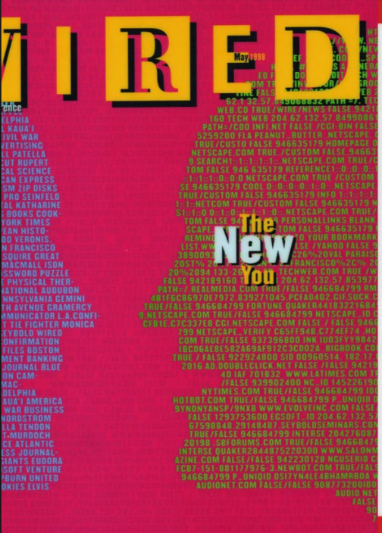
We made plently of progress, added great customer such as IBM, Microsoft, Ford and more. We got plenty of press. The story I am most proud of is the WIRED cover story entitled “The New You.” It was inspired by many of the innovations I led while I was there. The story addressed the promise of using person level data to create a more personal relationship between brands and consumers. It quoted my work analyzing massive amounts of data with artificial intelligence “Neural Nets” and statistical models to determine the next best message. It articulated the dream of where we could go with data and analysis.

While we made meaningful progress, including proving the value of digital advertising in seminal research picked up by academic journals and taught at leading b-schools, WPP was trapped in what Harvard professor Clay Christensen calls “the innovators dilemma.” Sir Martin wanted to spin-out my division, which I was all for, but his group CEO of Millward Brown, Bob Meyers, did not want to lose control of what he saw as the future of his billion-dollar business. It is classic innovators dilemma. Bob eliminated the R&D budget and ordered me to cut cost to the point of killing the dream of achieving the innovation.

I kept working for half a year to keep the innovation alive, however, the writing was on the wall. I had hit a dead-end. Since WPP’s first business was manufacturing shopping carts before transforming into the world’s largest advertising agency I sent a summary of the Innovators Dilemma article to Sir Martin in a miniature shopping basket. The article came with my resignation. I stayed on for another three months to ensure a successful establishment of a division that focused on the narrower goal of digital ad measurement. The division still operates to this day. I was committed to the broader innovation, even if I hadn’t yet found the right home for the “ROI Brain” innovation.

Attempt #3: E-Commerce Platform
The third experiment was to try a well-funded start-up specializing in e-commerce technology. I had been keeping my eye on a large start-up, Pandesic.

Pandesic had the security of industry titans Intel and SAP as joint-venture backers. Pandesic had over $100 million in funding, and had over 100 e-commerce customers including Adidas, SF Giants, eHobbies, ProFlowers. Most intriguing, they had a complete data set of advertising and sales data. They had a management team committed to pioneering one-to-one marketing. I was in! Here is the story The Industry Standard wrote explaining about why I joined Pandesic:
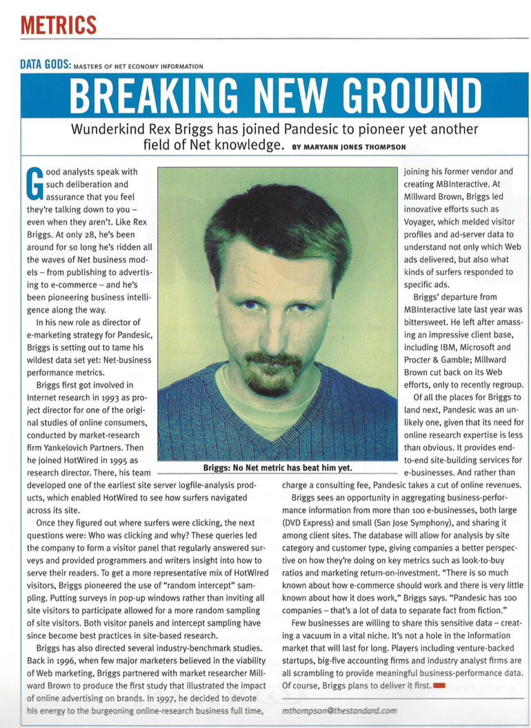

We were making great progress. But, as I understand it, Intel and SAP couldn’t agree on how the company would operate as a public company with SAP’s Codebase/Intellectual Property, and shut down the venture abruptly.

Amazon staffers heard about the closure. They flew me to Seattle. I met Jeff Bezos, and they offered me the role of running analytics for Amazon. But, after trying different versions of “big company” I wanted to experiment with building my own company that could serve more customers than Amazon.

Attempt #4: Start-up
In the unused room above the garage, I opened up shop. The name of the company: Marketing Evolution. The manta: “Test, Learn, Evolve.”

I didn’t take any funding. We built it one customer at a time. Ultimately, the “start-up” configuration has succeeded. We’ve attracted a brilliant team, and I’ve kept the lessons learned along the way in mind. Pacific Crest reports that less than 5 percent of SaaS start-ups achieve the revenue scale Marketing Evolution has achieved without taking outside capital. Marketing Evolution boasts a blue-chip list of customers including Allstate, Amgen, Best Buy, Coca-Cola, Cox, Century Link, DSW, MillerCoors, and more.

Forrester, the independent research organization that rates technology companies, named Marketing Evolution a leader in their latest Measurement & Optimization Wave report. Marketing Evolution outscored billion dollar companies such as Google, IRI, Nielsen and over 60 other companies Forrester reviewed.

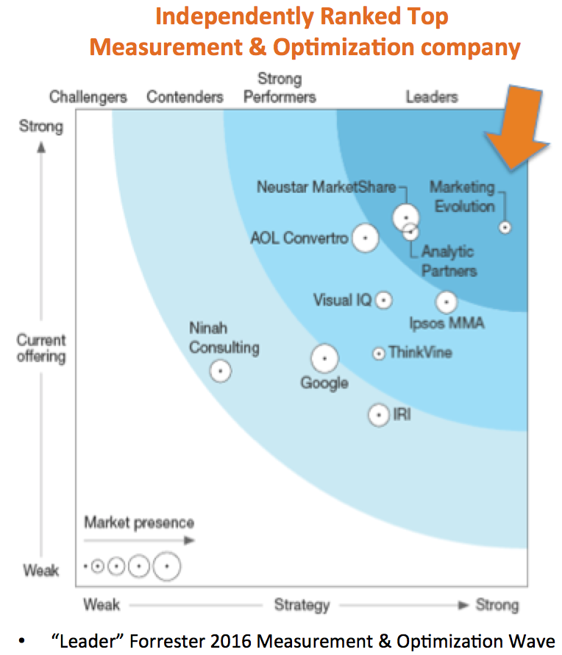

Gartner’s CEB Marketing Leadership Council has written a series of best practices based on Marketing Evolution’s ROI Brain. The Advertising Research Foundation awarded Marketing Evolution the “Gold Medal” in big data. We are most proud of the impact we’ve had on our customer’s business. CARFAX, became a customer last year. In one year, their business is up over 60 percent, media costs are down 19% and they estimate 6%-time savings. Looking across our enterprise customers, the average increase in advertising impact is 31% with a return on investment from the cost of Marketing Evolution of more than $20 for each $1 paid for the ROI Brain™.

The innovation found a home. Now, Marketing Evolution is entering a new chapter in the innovation journey. Zetta Ventures has become the first investor, and Marketing Evolution is embarking on globalizing the technology.

2. Experimenting with getting Big Data and AI into The Hands Of Business Decision Makers
What is the right way for massive amounts of data, analyzed by an AI brain, to get into the hands of business users? How does one distill down massive amounts of data and analysis into something a business-person can easily use on a daily basis? What is the man and machine interface? Should a marketer converse with a robot? Should the information be ever-present, and worn on your writs so you can glance at the ROI Brain any time you want? Should the ROI Brain be in the background, like an alarm, and only alert you when you need to take action? Or, should it be an immersive world that you goggle into?

We’ve experimented extensively with the ROI Brain™ interface. Below are some of the 20+ iterations of the interface we’ve experimented with to learn what would succeed. This is our version of the WD-40 story, where it took 40 attempts before finding the right formulation. The table shows the variety of designs explored to date.

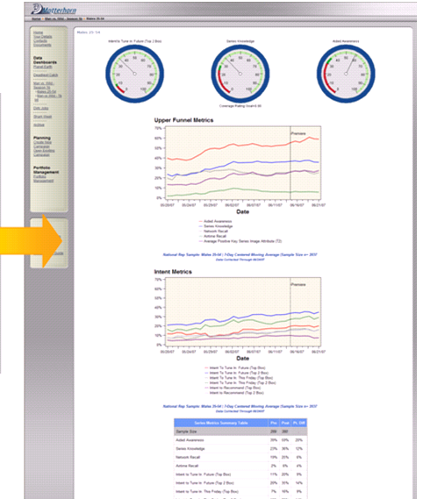  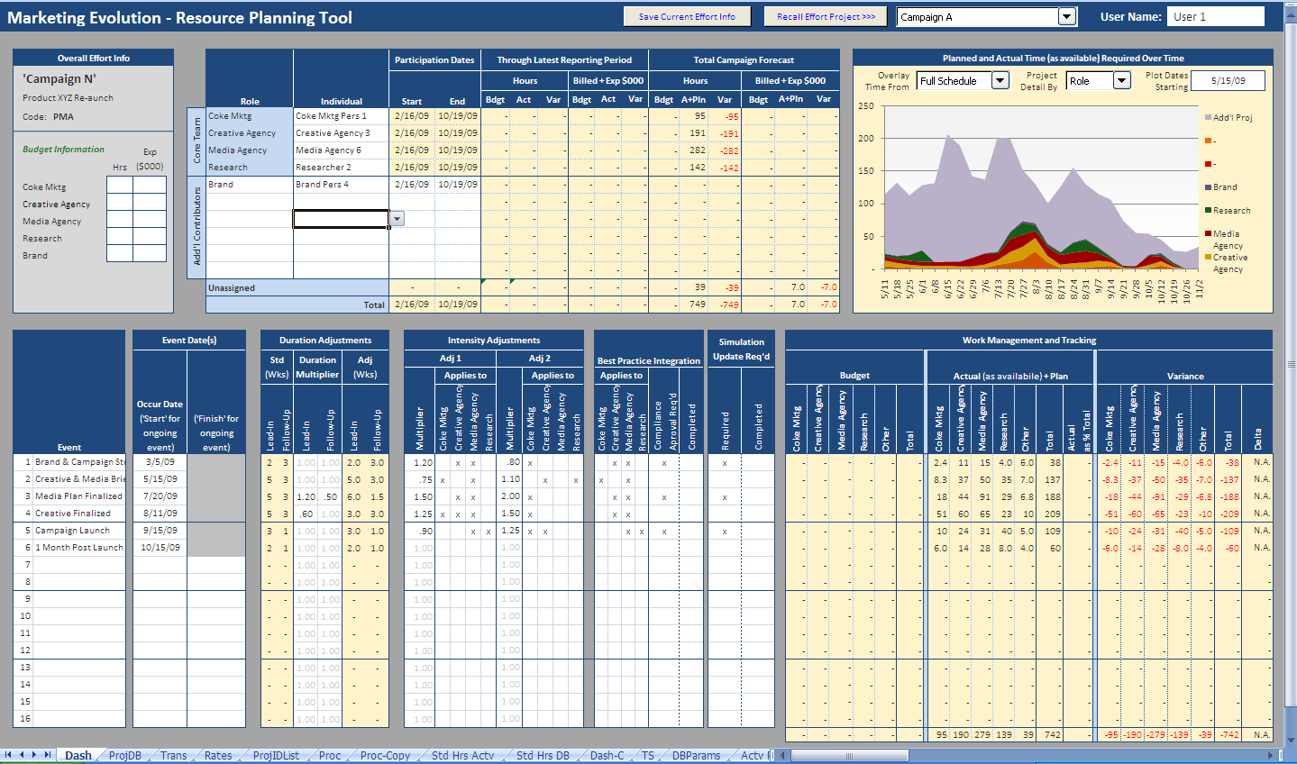 | 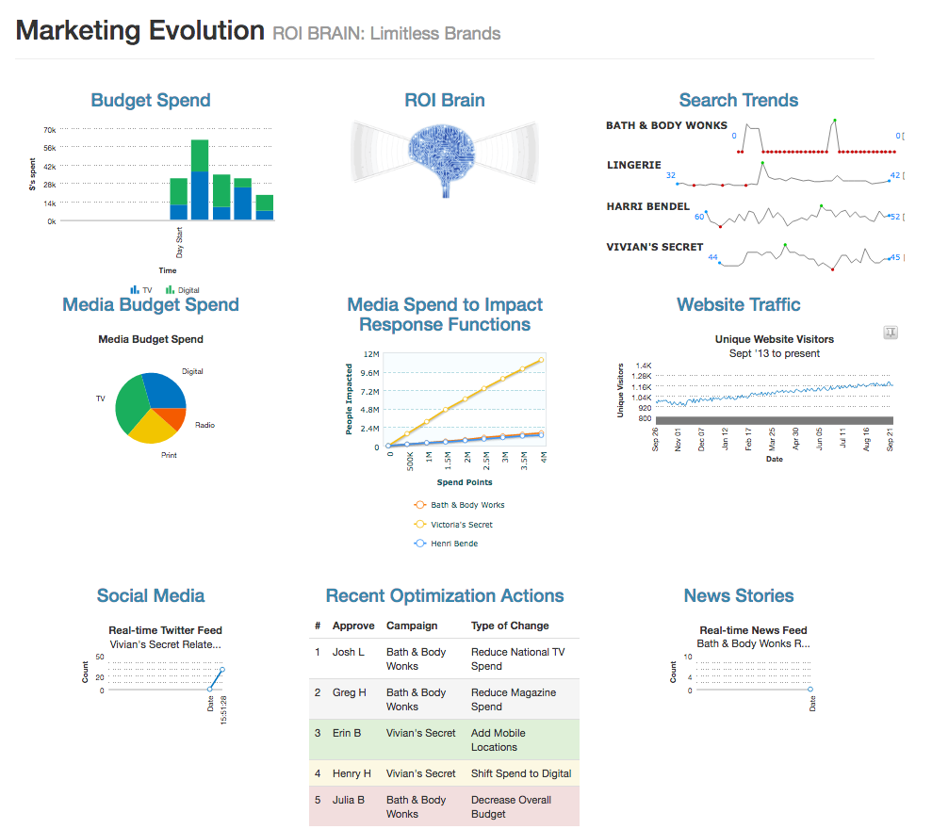 | 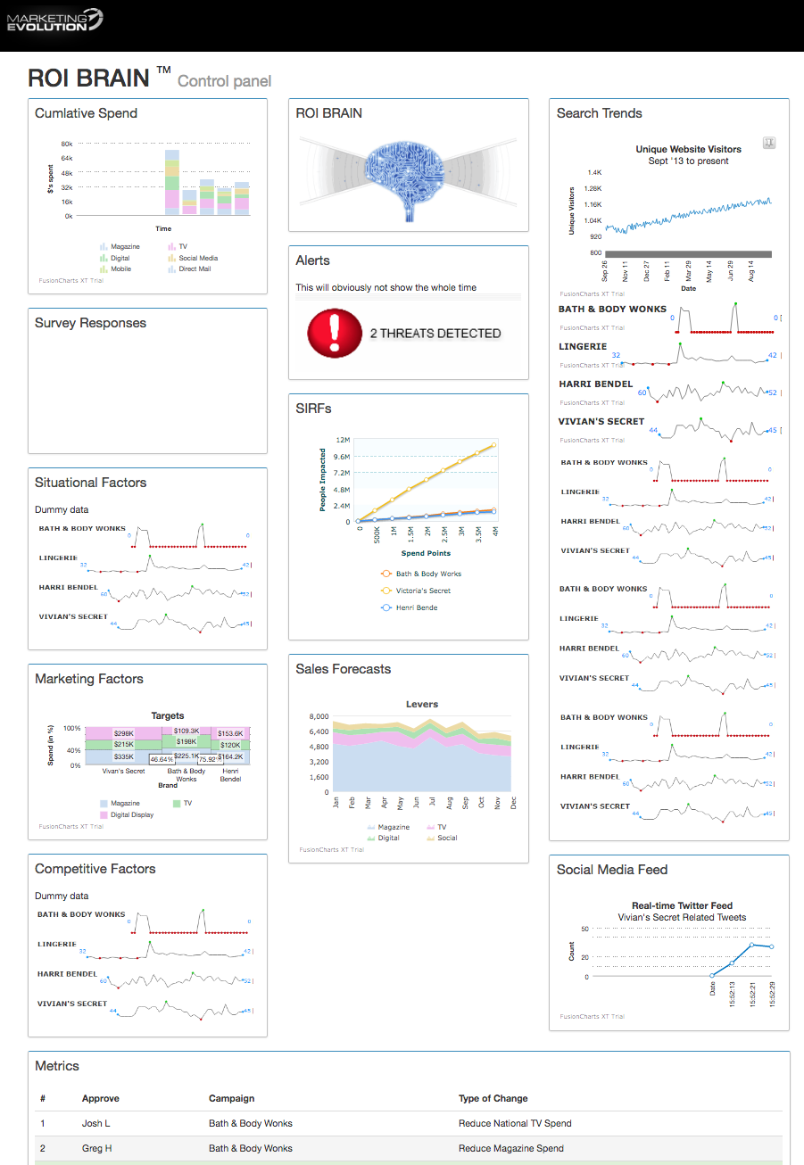
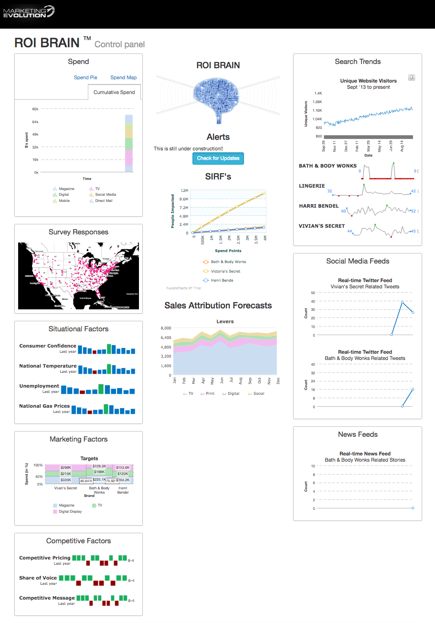 | 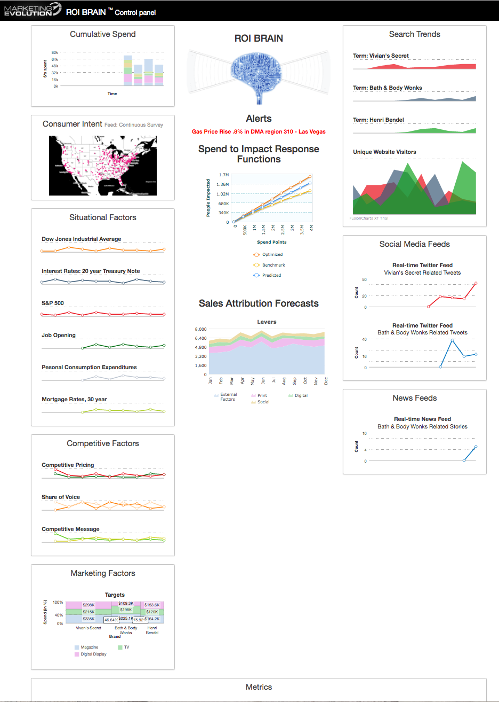 | 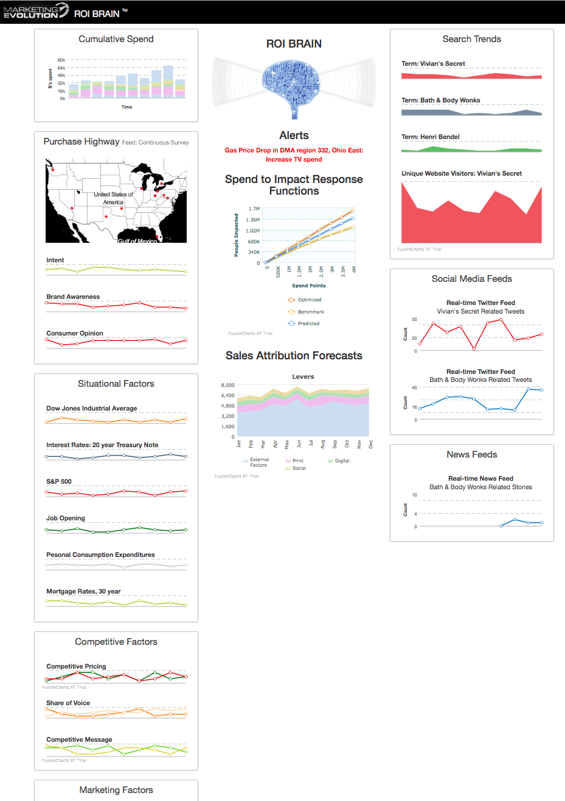
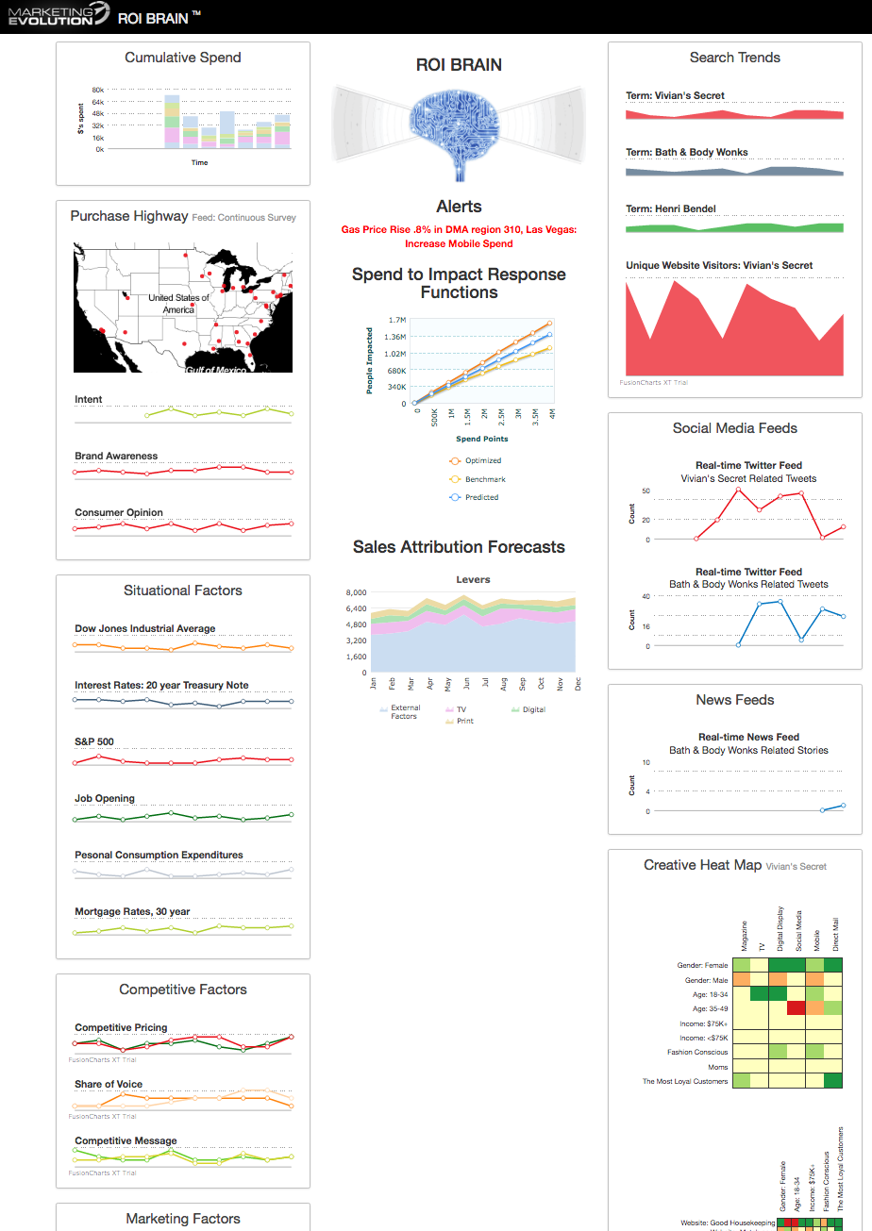 | 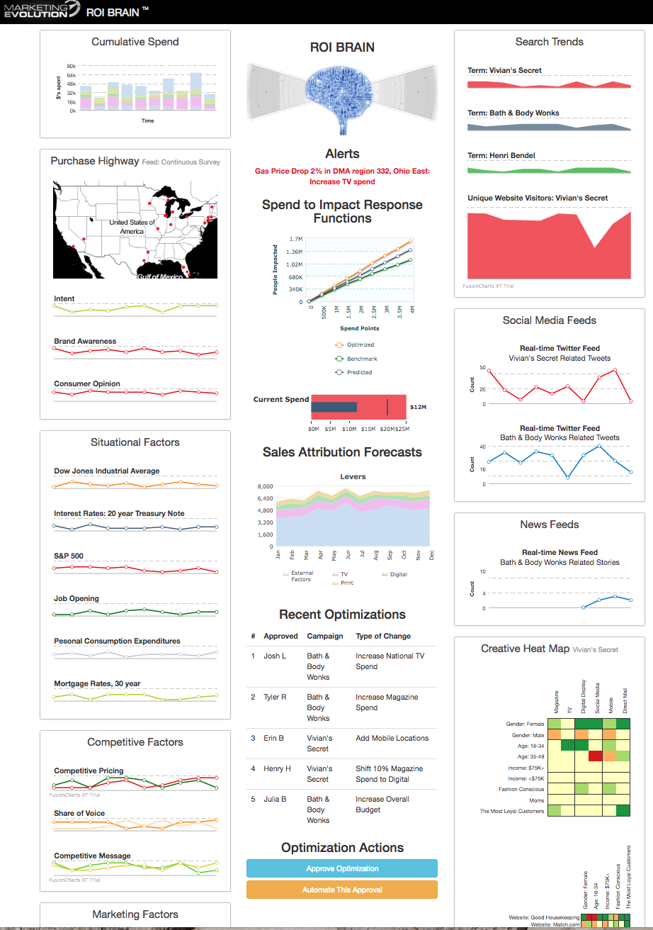 | 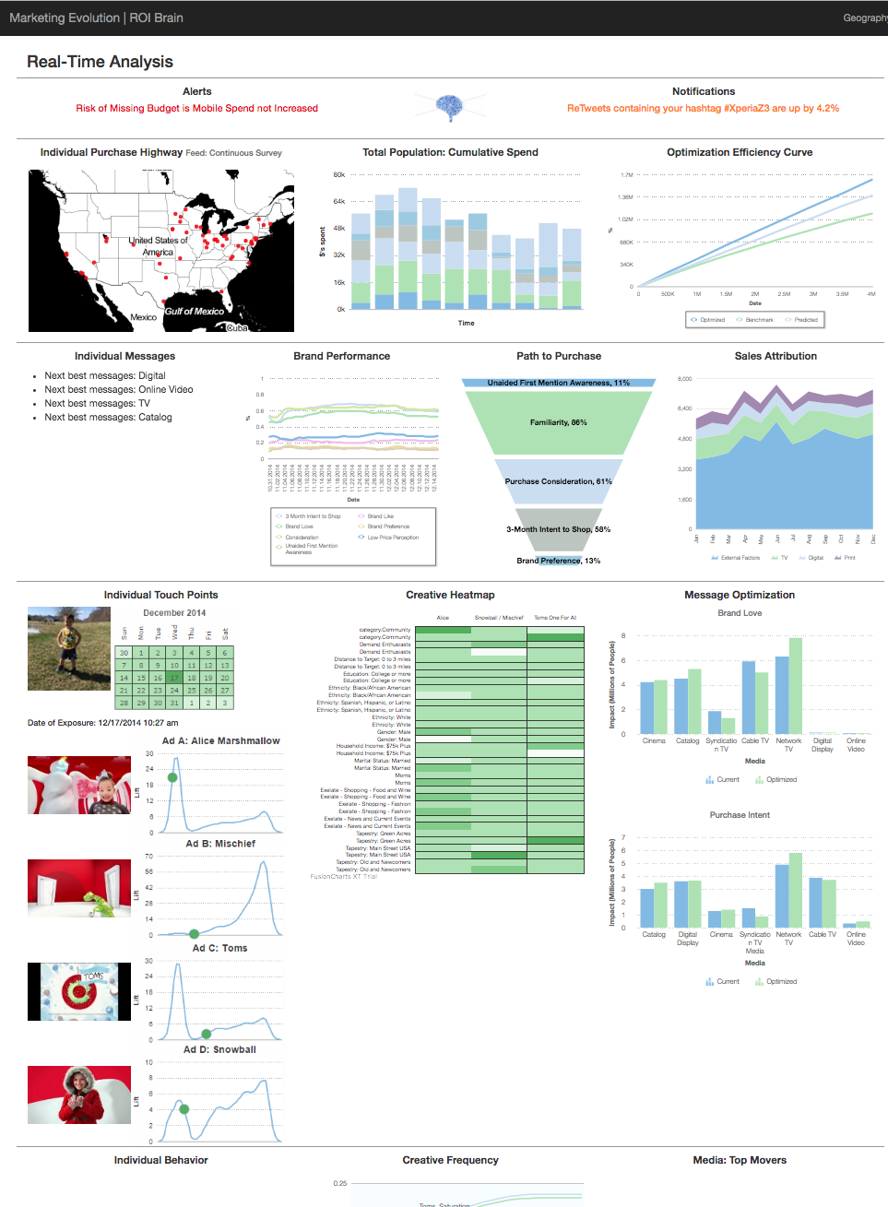
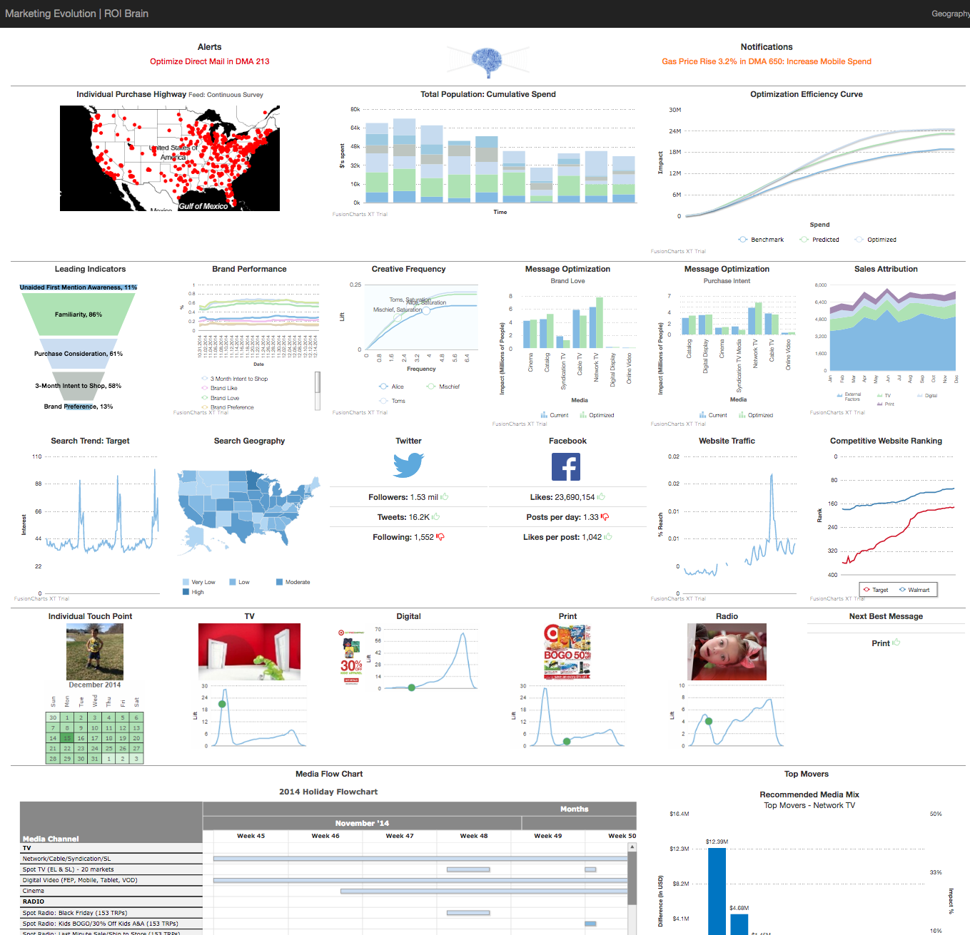 | 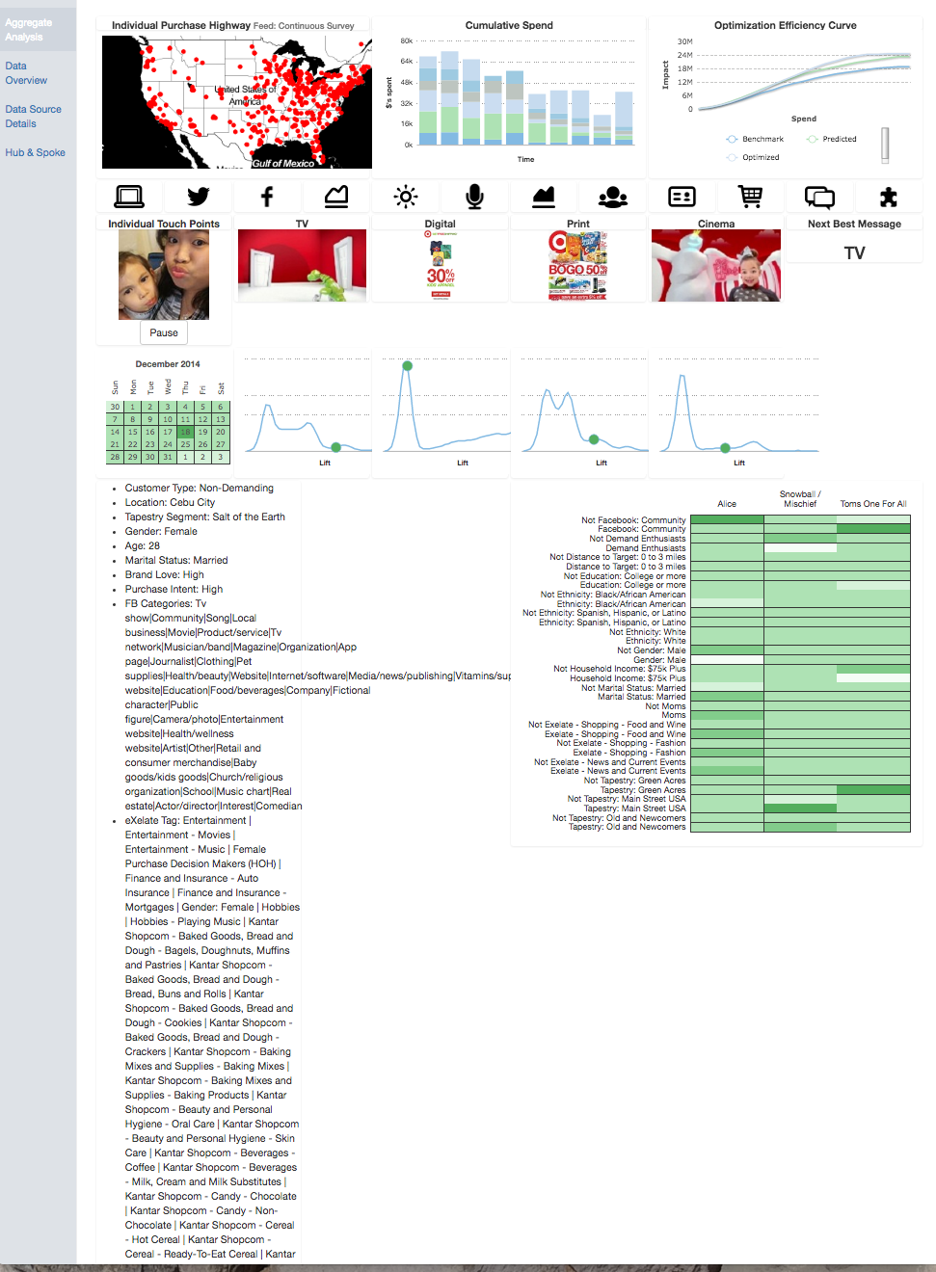 | 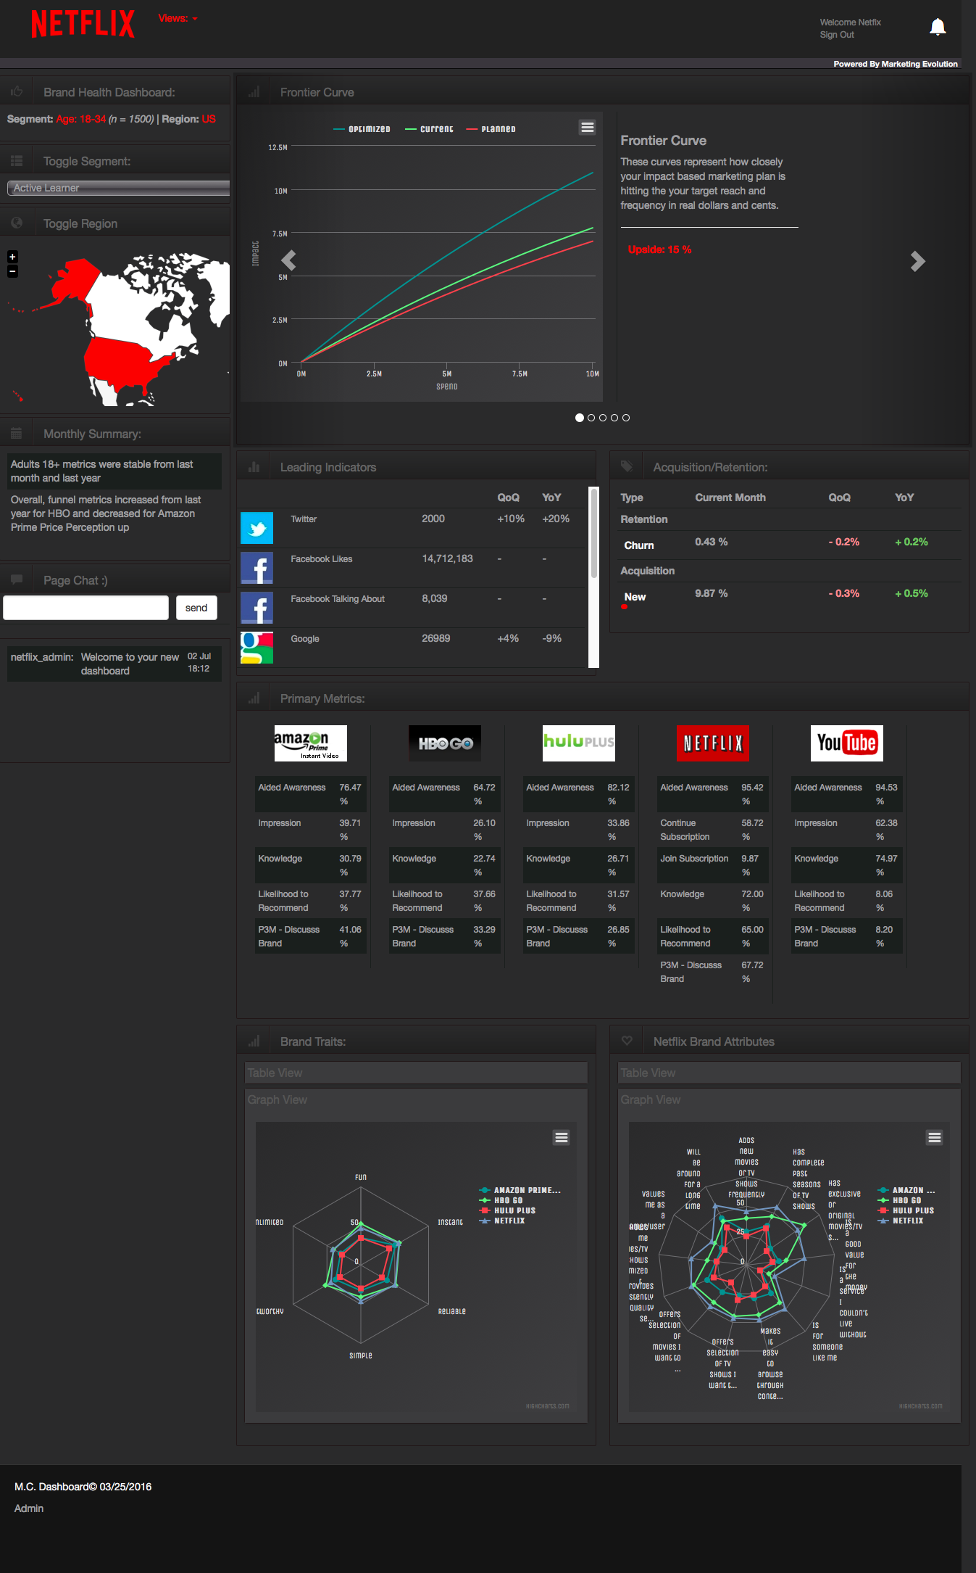
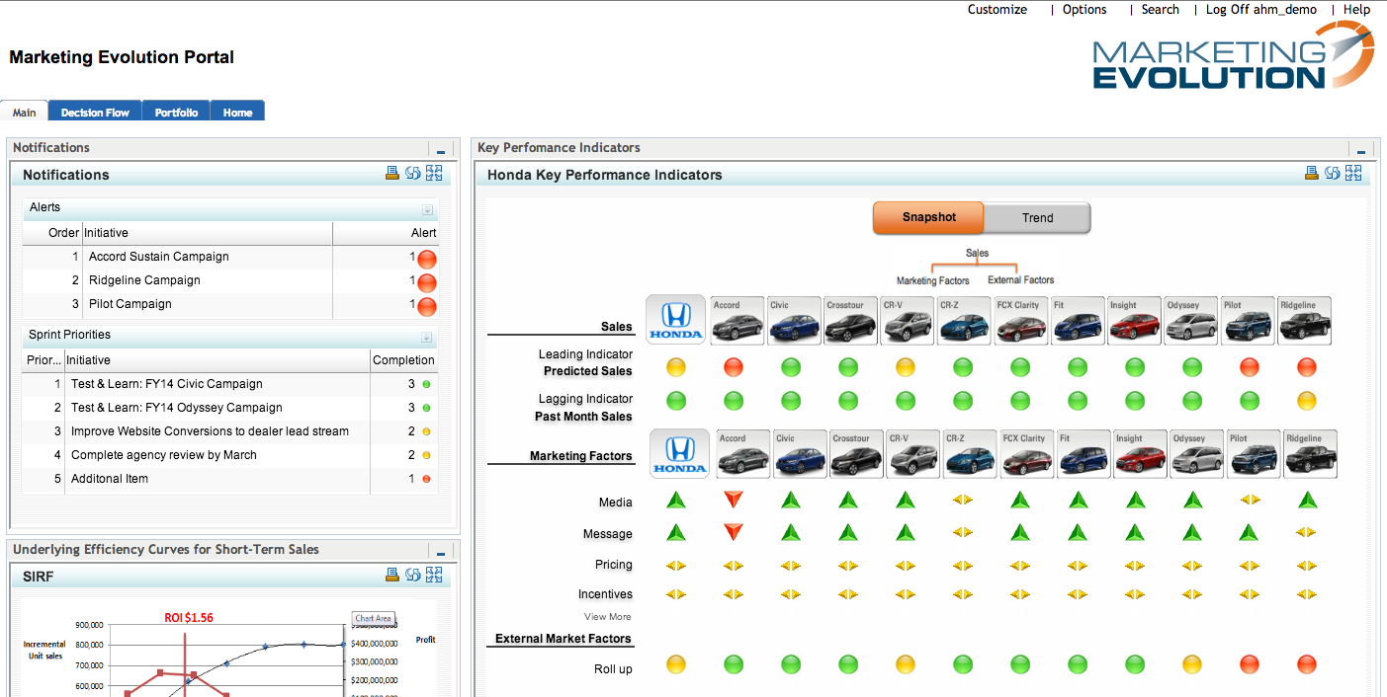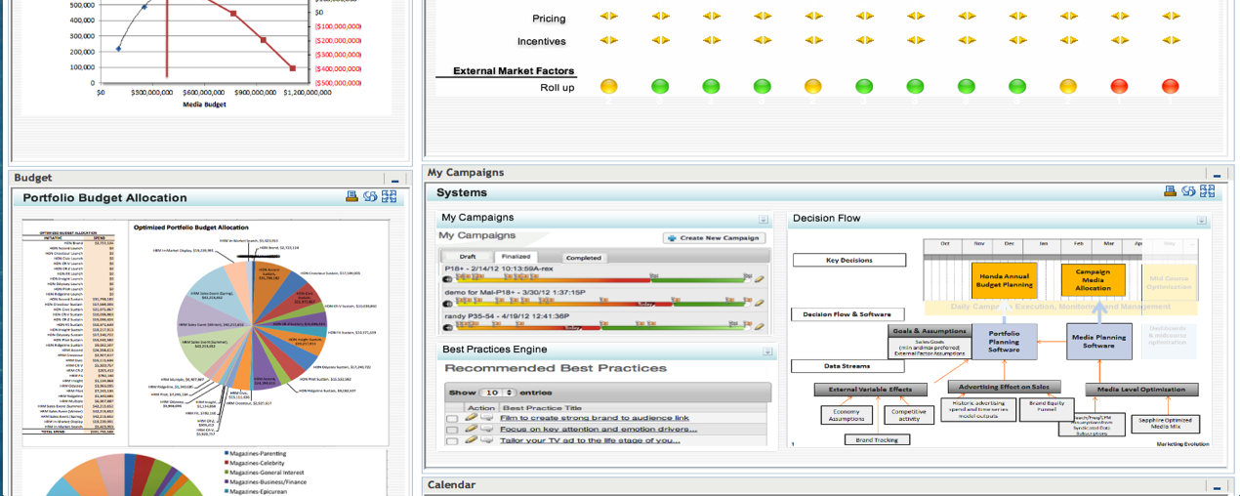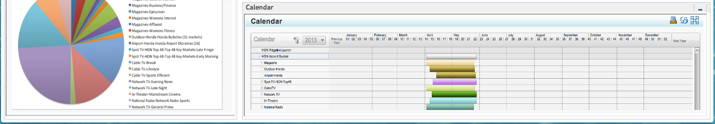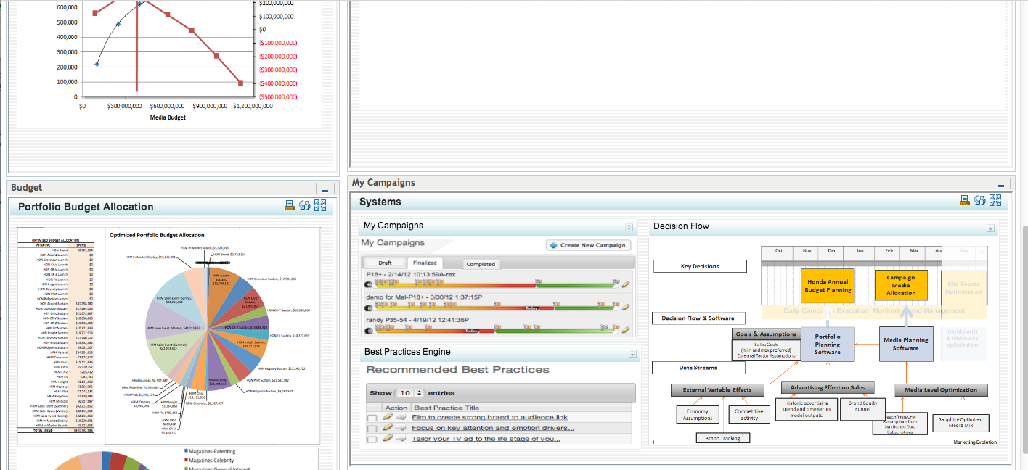 | 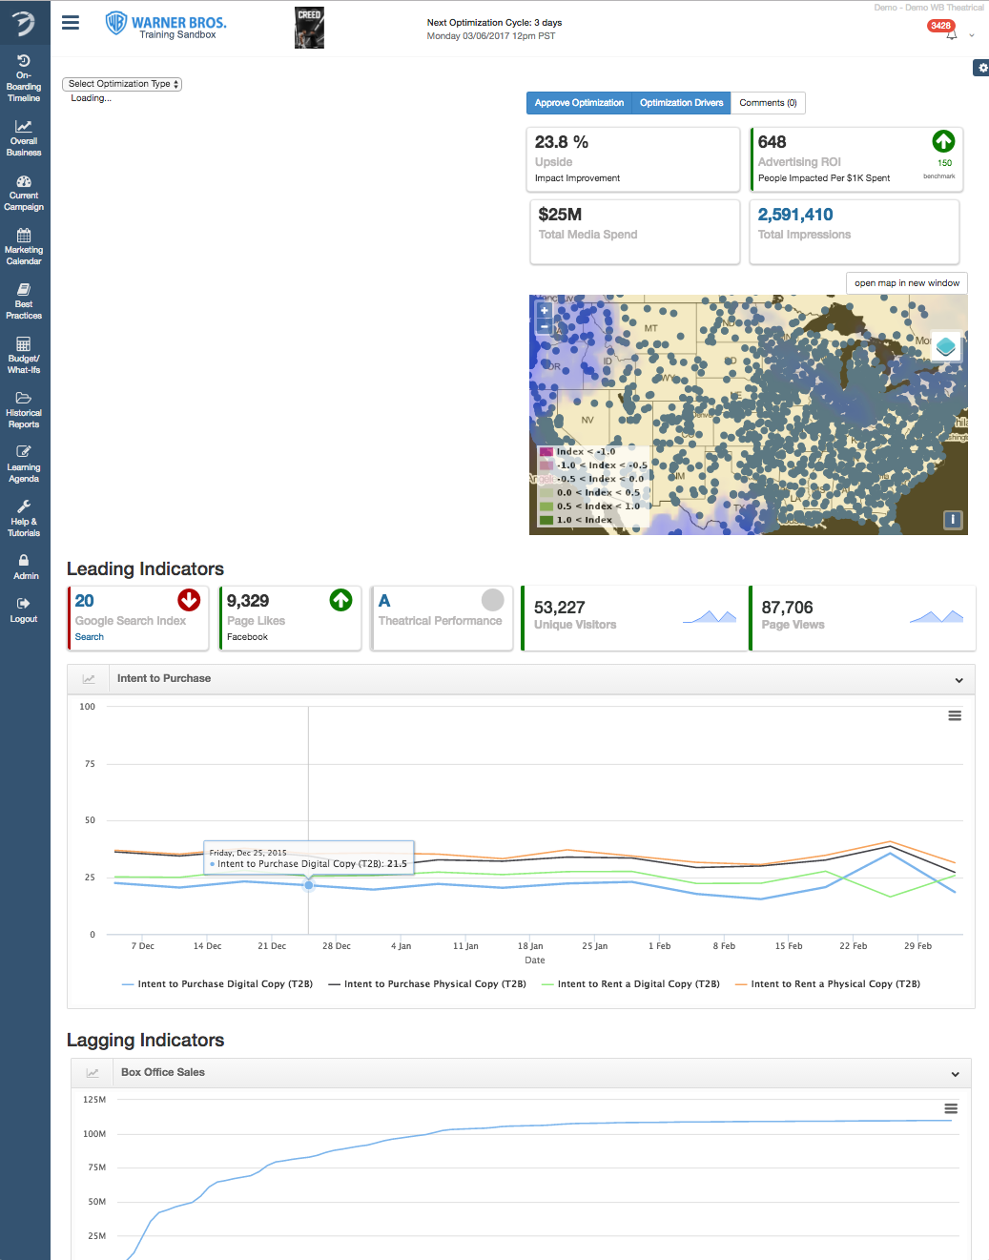 | 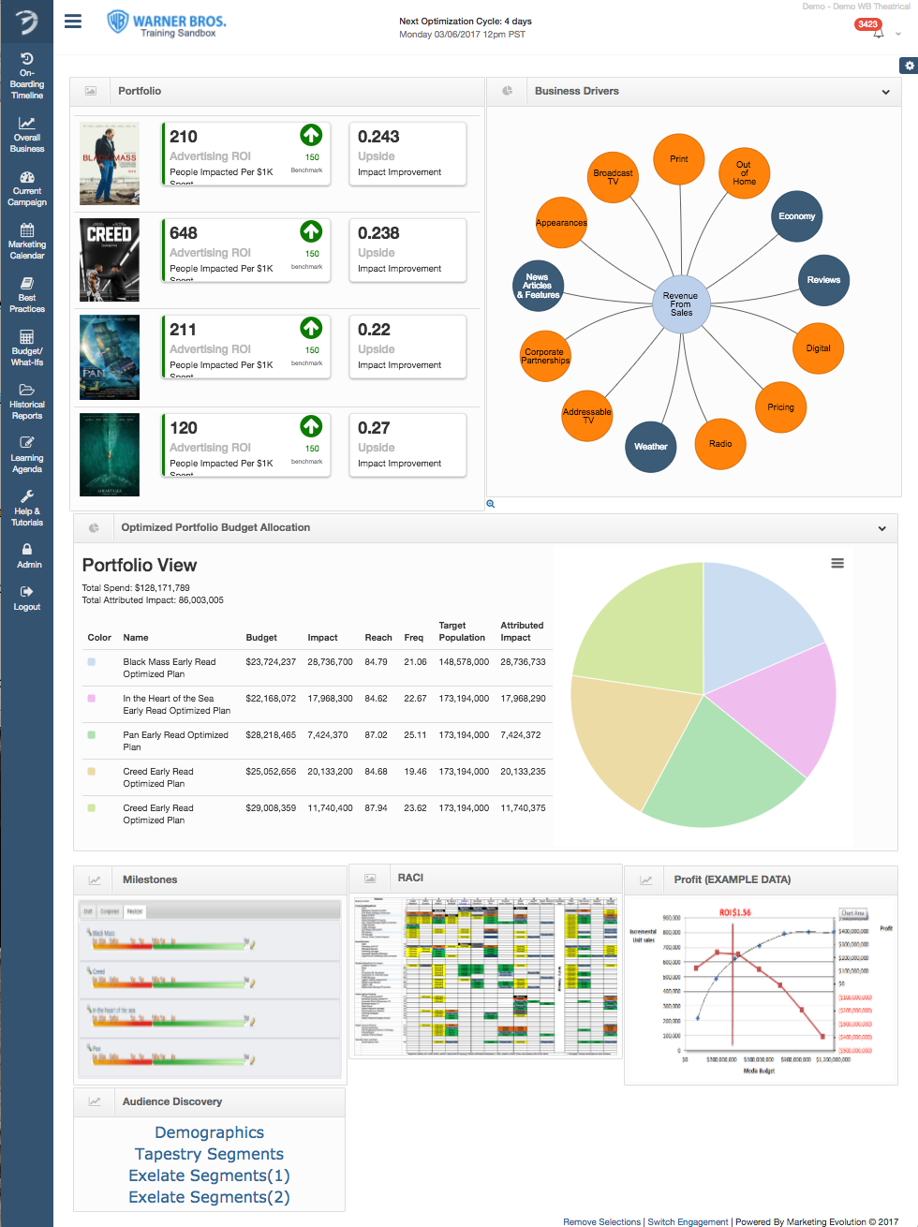
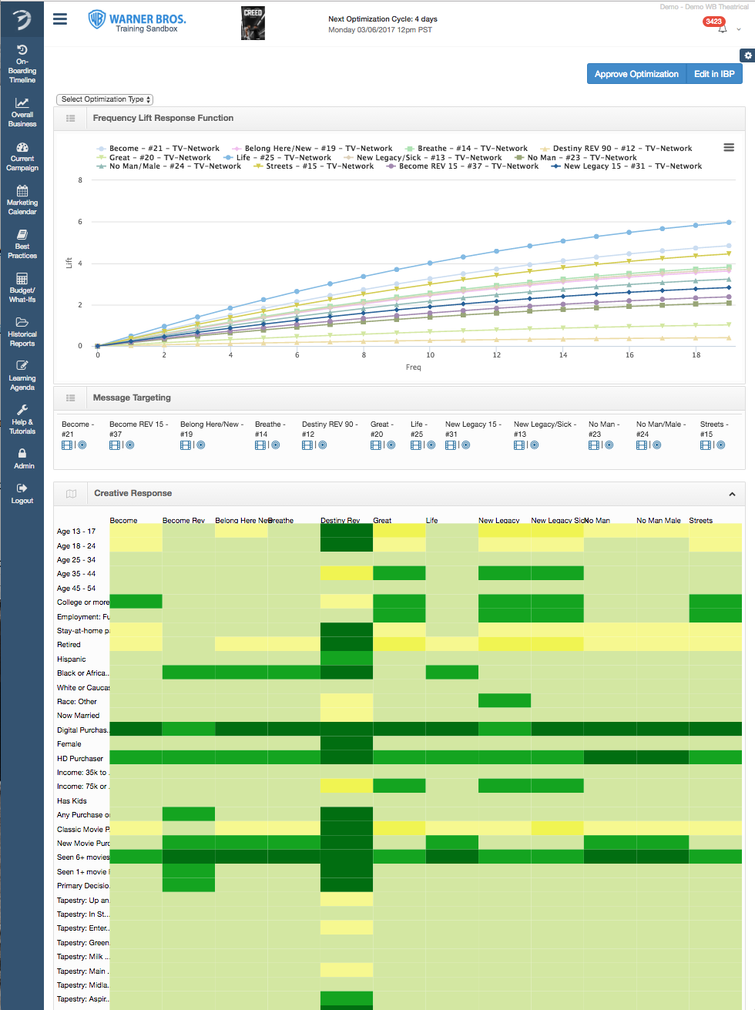 | 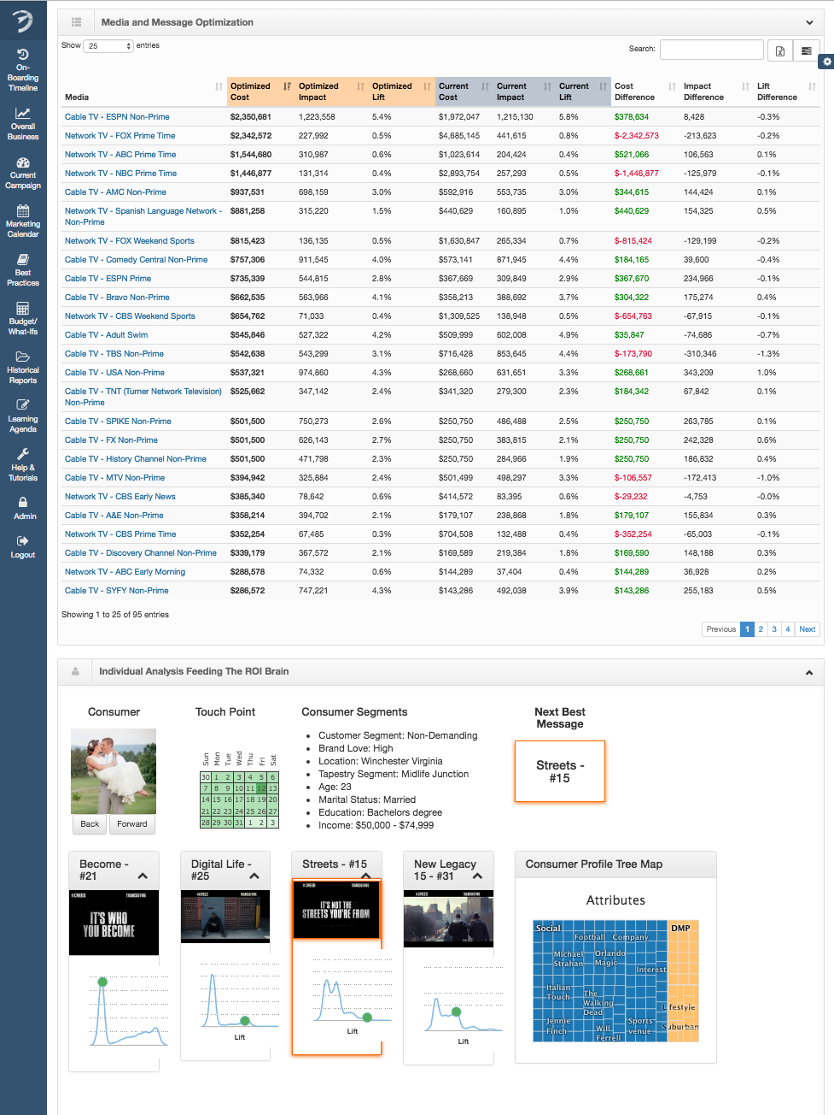 | The  Testing  Continues

We’ve experimented with the best ways to share the data. Big screen. Computer. Mobile device. Watch. You name it. We’ve tried it. Check out the short 3min video from Marketing Evolution.

Apple Watch: See the video (3min):
http://www.marketingevolution.com/watch/
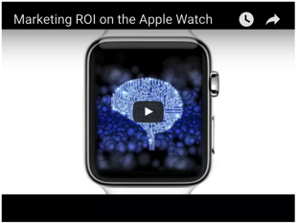

Read the story about Marketing Evolution’s ROI Dashboard’s delivered on Apple Watch: http://adage.com/article/cmo-interviews/obsessed-roi-app/298831/
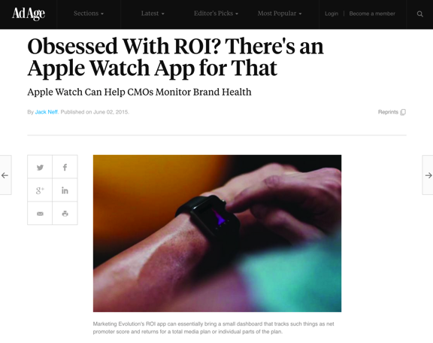

We’ve experimented bringing the ROI Brain™ to life in Virtual Reality (VR):

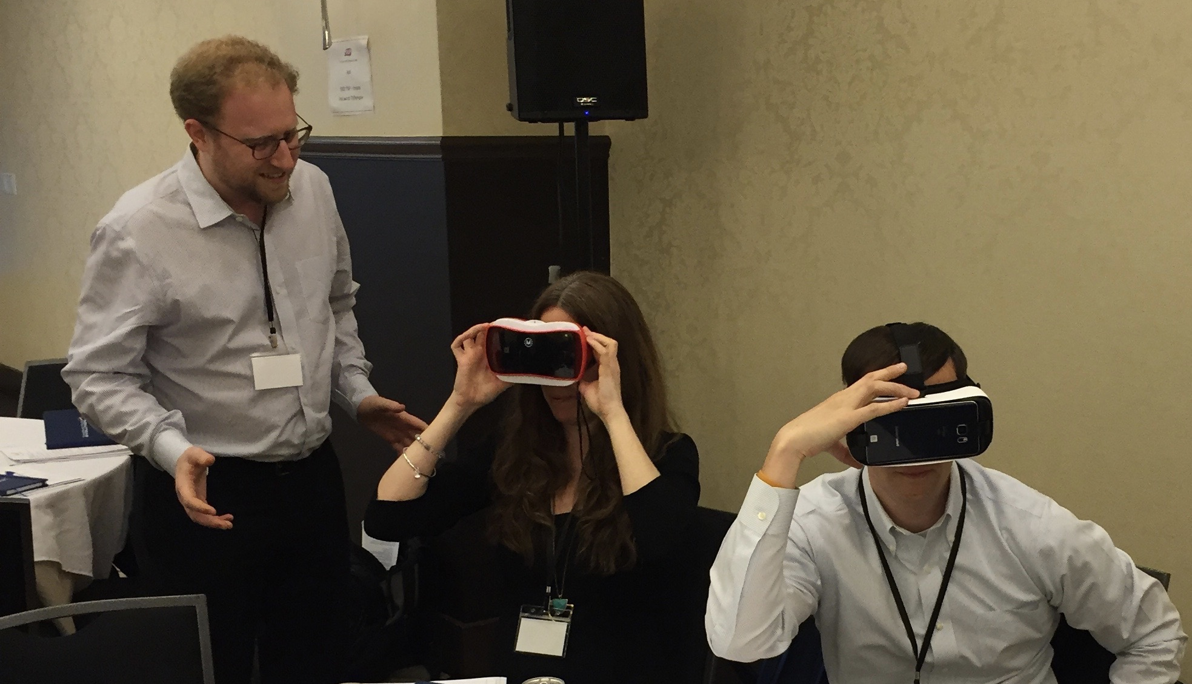

We’ve experimented with how to take our big data + AI + applications and get marketers attention. Specifically, we experimented putting the AI in a robot, and having it interact with people at the Masters of Marketing Conference.

http://adage.com/article/cmo-strategy/marketing-evolution-mma/300894/


Not all innovations succeed. We ultimately shelved both the VR and the robot because it made our technology seem more “science fiction” than “science fact.” When comparing the VR and Robot to hands on, in-person demonstration on a computer screen with a human guide, the hand-on human guide wins. The experiments revealed that it makes the ROI Brain™ less intimidating. It makes it easier to see how it will apply to the businessperson’s daily activities. It makes what we do more relatable, and increases sales rates. Enterprise software salespeople, your jobs appear safe from the robots – for the time being.

3. Marketing Experimentation:
With the recent investment of Zetta Partners, our focus is on accelerating the growth from over 40 percent in annual contract value to over 80 percent. To do so requires innovation in our marketing and sales models.

Most of the growth of Marketing Evolution to date has been referrals and word of mouth. Recently, we began a series of experiments with conferences, person-level advertising, account based marketing outreach. We have a list of 1000 marketers spending at least $10 million a year on advertising. We have proven we can increase ROI on average 31 percent, which equates to marketers getting back more than $20 back for every $1 they pay to activate the ROI Brain™. The challenge is that less than 10% of these marketers have heard of Marketing Evolution. To find the best ways to scale, we are systematically experimenting with test and control groups within the 1,000 list.

While these experiments are not nearly as sexy as creating robots that can help a businessperson optimize their marketing budget, the value to the company is directly tied to these systematic marketing experiments. As SaaS Capital reports, the number one factor driving shareholder value of a SaaS business is the rate of growth. 40 percent is good. Getting above 80 percent can double the valuation, thus allowing Marketing Evolution to raise a Series-B at attractive terms to fund additional innovation. We plan to make the ROI Brain™ available to every business, large and small, on a global scale. To do that, we need to innovate our way to more than double our current growth rate so we can add more fuel to the fire with additional capital.

Conclusion:
At the founding of Marketing Evolution, the mantra was “Test, Learn, Evolve.” It was a message to marketers. It was a message to ourselves. We have a lot more experimenting to do, but as of today, we finally feel the wind at our back.

